DOWNTOWN DEVELOPMENT
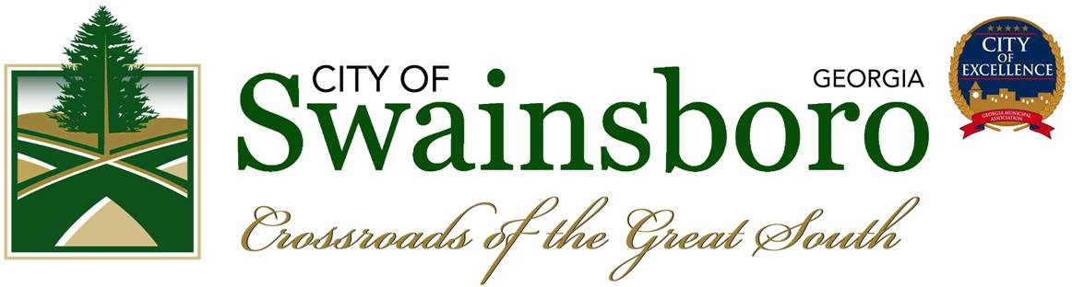

JOB TITLE: Director of Downtown Development and Main Street Coordinator

DEPARTMENT: Downtown Development, City of Swainsboro

JOB SUMMARY: The Director is responsible for creating, planning, coordinating, and marketing Swainsboro's Commercial Downtown District and Main Streets Program.

OVERVIEW:
Downtown is certainly the most historically rich and culturally significant place in all of Swainsboro. The City of Swainsboro is searching for a qualified, passionate, energetic, and creative individual to lead Downtown's extensive revitalization strategy as Director of Downtown Development. The success of our Downtown District as the economic center of Swainsboro will require innovative approaches to marketing and economic development. Our new Director will work with a vast array of partners to ensure that each business is successful, and that Downtown is a fun and creative place to visit, shop and explore.

THE IDEAL CANIDATE POSSESES:
- Strong leadership, organizational, communication, interpersonal, and writing skills
- Uncanny ability to think beyond the box and creatively solve problems
- Passionate about community service, event management, marketing and building strong partnerships with individuals and organizations
- Exceptional, outgoing (yet introspective) personality who is cool under pressure, to deal with deadlines and the occasional adverse situation
- Emotional availability, elevated sense of humor, and better than average charisma

RESPONSIBILITIES INCLUDE:
-Managing daily office operations; general office duties such as creating and maintaining files, typing correspondences, and regularly meeting with Downtown business owners, partners and prospects
-Develop and implement strategies and programs to retain and recruit businesses Downtown for the purpose of economic restructuring
-Develop marketing materials and programs to promote Downtown businesses, entertainment opportunities and Swainsboro's Main Street Program (both online and off)

-Attend Downtown and city events
-Plan and coordinate special programs and events focusing on Downtown usage, commerce and development, recruit of volunteers, preparing press releases and ordering supplies and materials
-Establish and maintain relationships with business leaders, community groups and Downtown partners
- Track Main Streets Program progress, prepare monthly reports and implement program strategies and goals
-Conduct monthly meetings with the Downtown Development Authority (ODA). Support the implementation of strategies from these meetings and keep Board members informed on progress of special projects
-Assist with Historic Preservation, Downtown Merchants Association, and other Boards
-Coordinate efforts to increase tourism within the Downtown area with other City personnel
-Maintain the City of Swainsboro's website and social media pages
-Participate in depth required training
-Plan, promote, implement, and evaluate projects and programs that spur Downtown growth and enhance economic development
-Attend and report progress of the DOA to Swainsboro's City Council
-Develop and conduct public awareness programs
-Oversee redevelopment of City owned prope1ties and public spaces
-Assist individual property owners and tenants with physical improvement projects with approval of the ODA
-Developing sustainability plans for programs and projects that includes grants, loans and membership
-Assist property owners with the leasing and/or redevelopment of available commercial and residential space in the Downtown district
-Create and support City Codes, Ordinances and Zoning regulations vital to the success and growth of Downtown
-Assist with the design of Downtown properties; provide resources and contacts with design professionals
-Organize public/private partnerships to enhance Downtown Development and the Main Streets Program
-Oversee the Mainstreet Market. Assist and work closely with the market manager
-Perform other related duties as assigned

QUALIFICATIONS:
Education: BS, BA, BFA, MBA, or MFA (Required)
Experience: Downtown/Economic Development, Business/Marketing, Management, Related Experience, Volunteering, Grant writing experience for state and federal grants (Required)

Computer Programs: Microsoft Office Suite, Internet Explorer, Social Networking, Photoshop (or similar Design Program), WORDPRESS (Required)
Salary: FT Employment, Salary contingent on experience, qualifications
Expected Start Date: Dependent on applicant

APPLYING FOR THIS POSITION:
Please read these submittal instructions carefully. Applications that do not follow instructions will not be considered/or review

Employee Requirements:
Background check, reference check and drug screening.

By Mail:
Please mail the following 4 (four) documents to the address below by the date below:
- Application (Downloadable File on City's website: www.cityofswainsboro.org
or available for pick-up at City Hall at 101 West Main Street)
- Resume (please include 3 references)
- Cover Letter (detailing your interest and qualifications)
- Statement (at least 250-word statement regarding your feelings on the importance of the Downtowns and your ideas and expectations for growth and development of Downtown Swainsboro)

All Applications must be postmarked by: April 25th, 2022
,
City of Swainsboro
c/o ODA Director Position
P.O. BOX 600 Swainsboro, GA 30401

By E-Mail:
Please e-mail the following 4 (four) documents in WORD or PDF format with the Subject Header: Director Position to downtown@cityofswainsboro.org by the date and time below (other formats will not be reviewed):
- Application (Downloadable File on City's website: www.cityofswainsboro.org)
- Resume (please include 3 references)
- Cover Letter (detailing your interest and qualifications)
- Statement (at least 250-word statement regarding your feelings on the importance of the Downtowns and your ideas and expectations for growth and development of Downtown Swainsboro)

All Applications must be received by: April 25th
,
2022 at 4:30pm.

Qualified prospects will be contacted promptly, and interviews will be conducted within the month. Initial review of applications begins April 2nd. For more information on Swainsboro and Downtown, please visit: www.cityofswainsboro.org

